Pin Mappings

STM32 -> Toshiba CCD  
1 | GND -> Pin 22 - SS  
2 | 3V3 -> Pin 1 - V_DD and Pin 2 - V_AD  
3 | PA0 -> Pin 3 - ICG  
4 | PA2 -> Pin 5 - SH  
5 | PA3 -> Pin 21 - OS  
6 | PA6 -> Pin 4 - ΦM  
  
STM32 -> HC-05  
7 | PA9 -> RXD  
8 | PA10 -> TXD  
  
MB102 Power Supply - > STM32  
From MB102's J6 (Top of board) 8-PIN section  
9 | Pin 1 - 3.3V -> 3V3 (next to pins 34 and 37)  
10 | Pin 2 - GND -> GND (next to pins 34 and 37)  
  
MB102 Power Supply - > HC-05  
From MB102's J6 (Top of board) 8-PIN section  
11 | Pin 7 - 5V -> VCC  
12 | Pin 8 - GND -> GND

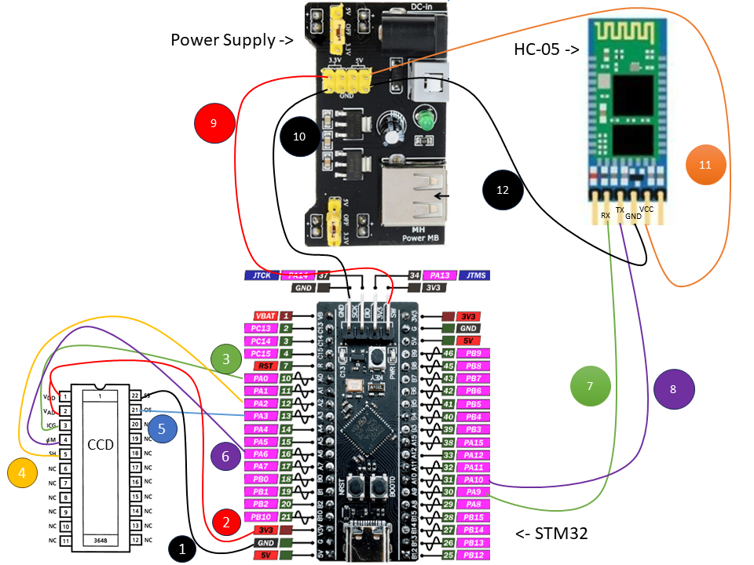

# References

Toshiba TCD 1304DG Datasheet:

<https://www.spectralproducts.com/pdf/ToshibaTCD1304.pdf>

HC-05 Schematic:

<http://www.hiletgo.com/ProductDetail/2152062.html>

Power Supply Datasheet:

<https://www.handsontec.com/dataspecs/mb102-ps.pdf>

STM32F401 Board Pinout

<https://mischianti.org/wp-content/uploads/2022/02/STM32-STM32F4-STM32F401-STM32F401CCU6-pinout-high-resolution.png>

STM32 More info

<https://mischianti.org/weact-stm32f401ccu6-black-pill-high-resolution-pinout-and-specs/#Datasheet>

stm32f401 chip datasheet

<https://www.st.com/resource/en/datasheet/stm32f401cb.pdf>